Jacob Carson
Energy Environment and Society
April 25, 2017
The Problem With Corn Ethanol

It is no secret that America is heavily dependent on gasoline and corn. The cause for this dependence is because both are extremely good at what they do. Gasoline is a reliable, cheap, energy packed transportable fluid and corn is versatile, dependable, and grown all over the United States. It is not surprising then that when faced with a growing need to become more energy independent and combat climate change America would use corn as gasoline’s substitute. This would be done through ethanol. Unfortunately, corn ethanol is an extremely inefficient fuel source that hurts both the environment and America’s economy.
America, like much of the world, has sought to increase the use of biofuels (fuels made from biological rather than geological processes) for a variety of reasons. These reasons are typically dominated by a need to reduce fossil fuel consumption and increase energy independence. The way America has gone about increasing biofuel production though is quite different than that of Europe or Central/South America (predominantly Brazil). The world as a whole has increased its production of biofuels over the last ten years, by about 400%, with America keeping at that same rate (Figure 1). Where America differs with Europe is that America produces more ethanol and Europe creates more biodiesel (Figure 2). It is important to note that biodiesel is a much friendlier fuel to the environment. To be specific, as of 2017 the EU has required that biodiesels produce 50% less greenhouse gasses than their fossil fuel counterparts (Shikida). This is substantially more than the amount of greenhouse gasses saved from ethanol in America, which will be broken down later in the paper. Ethanol is not intrinsically bad for the environment, but the way America has gone about its production is.
Figure 1, World Biofuel Production by Region Figure 2, World Biofuel Production by Type
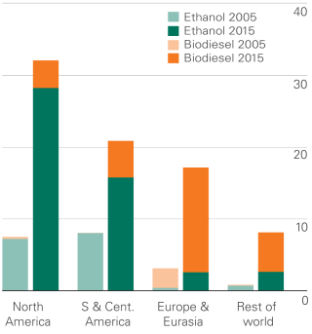
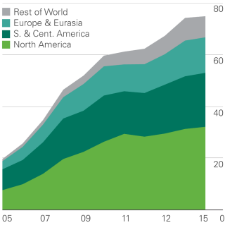
Figure 1, World biofuel production by region, with year on x-axis and million tonnes oil equivalent on y-axis. Note that North America’s production is 94% from America.

Figure 2, World biofuel production by type, with region on x-axis and million tonnes oil equivalent on y-axis.

The question remains however, why is corn ethanol bad? Simply put, it is because corn ethanol requires nearly as much energy to make as it provides, or net energy. In the United States average corn ethanol production has a net energy of 1.38 (Table 1). This is incredibly low. To compare Brazilian sugarcane ethanol has a net energy of about 10. When examining the net energy factors of corn ethanol the factors become quite evident as: fertilizer, irrigation, processing steam, and electricity require too much energy in the production of ethanol. An even more important point is that the only reason why the ratio is not nearly 1 (within error) is because of the co-product credits, which are byproducts of corn ethanol processing like corn oil and corn husks which can be recycled to other industries. Because this ratio is so low corn ethanol simply is not an acceptable main stable fuel source, especially for an industrialized country like America.
Table 1, Corn Ethanol Net Energy Breakdown
Another important set of calculations to demonstrate the inefficiency of corn ethanol is to look at its environmental impact, since one of the main reasons for its use is to reduce the impacts of climate change. To do this the scenario of replacing all of the United States’ gasoline use per year with ethanol as these are directly comparable fuels. To start, if the United States were to switch from all its gasoline use to ethanol greenhouse gas emissions would be reduced by 16.69% from the total emissions generated from using gasoline. While this may sound somewhat worthwhile, the amount of land needed would be 1.02*10^10 acres, which is more than the total arable land on earth. Assumptions not provided in Table 2 were that no carbon is sequestered from corn production, this is due to farming practices in America where root systems of corn are not allowed to stay in the soil and are tilled up. Another assumption not mentioned is that the amount of ethanol currently in use for gasoline replacement was not considered in the total fuel use.
Table 1, Energy used to make ethanol from corn in BTU’s per gallon ethanol.

Table 2, Replacement of United States Gasoline With Ethanol Calculations and Implications
Assumptions
Gasoline CO2 emission | 2.03E+00 | kg CO2/liter
US gasoline per year | 5.43E+11 | liters
gasoline energy density | 3.42E+01 | Mj/liter
ethanol energy density | 2.09E+01 | Mj/liter
energy to get corn ready for ethanol | 3.77E+04 | btu/acre
CO2 generated per ethanol energy production | 8.24E-05 | kg CO2/btu
acres in US used for corn ethanol | 3.60E+07 | acres
ethanol energy per liter | 2.14E+04 | btu/liter
gasoline production CO2 | 1.44E+00 | kg CO2/liter
Liters of ethanol produced per acre | 8.66E+01 | liters ethanol/acre
total agricultural land in US | 9.15E+08 | acres
Calculations
CO2 generated from us gasoline | 1.88E+12 | kg co2
CO2 generated from us ethanol if all ethanol | 1.57E+12 | kg co2
percent decrease by going all ethanol | 16.69%
land needed for all ethanol | 1.02E+10 | acres
percent increase in total acres | 28370.00%
land for ethanol compared to total agricultural land in us | 1020.13%
While the inefficiencies of corn ethanol are pertinent, it is still necessary to understand its merits. One of those being that corn ethanol is still a better alternative to gasoline when it comes to carbon emissions. The gasoline industry will likely never absolve itself from nearly complete carbon dioxide emissions, as carbon dioxide scrubbers will never be economically viable on cars. This is counter to technological advances in corn ethanol where production lines are becoming more efficient and new cellulosic corn ethanol looks to reduce the energy inputs needed by half (Lorenz).
Table 2, Replacement of United States gasoline with ethanol calculations and implications. See attached excel document for further source reading and calculations.

Another merit to corn ethanol is that it is a major revenue stream directly and indirectly for millions of Americans. Similar to the coal and oil industry this point is not to be overlooked as impacting corn ethanol will lead to potentially devastating consequences for communities nationwide. It’s important however to understand that this is not a new phenomenon as technological innovation as always left some in disarray. The economic inefficiency of the corn ethanol industry is exemplified by the billions used in corn subsidies to farmers.
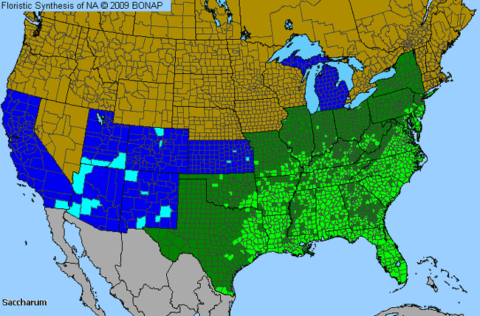
A third point to be made is that America already has much of the agricultural infrastructure to promote corn ethanol, as oppose to sugar cane ethanol. This however is simply because the investment has not been made. If America wants to become serious about ethanol production sugar cane is the only viable option, and luckily it is possible. Sugar cane requires lots of sun, rain, and warm temperatures, and much of the south eastern United States is able to sustain this growth, as shown in Figure 3.
Figure 3, Sugar cane growth viability in the United States. Light green regions show where sugar cane is currently grown, dark green show where sugar cane could be grown semi-efficiently, and blue regions show where sugar cane could be grown with extensive support.

Figure 3, Sugar Cane Growth Viability in United States

The bottom line is that corn ethanol is too inefficient of a fuel to be used on a large scale. With a net energy value of 1.38 it cannot compare to other biofuels or the current fossil fuels being used in the United States and world today. For corn ethanol to ever be efficient it will require even more subsidies and invest from the United States government, which at this time is not an acceptable strategy to combating climate change and energy independence. In this writers opinion corn ethanol should be abandoned by the United States and the money invested into it should be used in other sustainable industries such as mass transportation or sugar cane ethanol production.

Works Cited

Figure 1 and 2:
British Petroleum. "Biofuels Production." Bp.com. BP Global, 2016. Web. 24 Apr. 2017. <http://www.bp.com/en/global/corporate/energy-economics/statistical-review-of-world-energy/renewable-energy/biofuels-production.html>.

Table 1:
Morris, David, and Irshad Ahmed. How Much Energy Does It Take to Make a Gallon of Ethanol? Washington, DC: Institute for Local Self-Reliance, 1992. The Institute for Local Self-Reliance, Aug. 1995. Web. 24 Apr. 2017. <http://large.stanford.edu/courses/2014/ph240/dikeou1/docs/ethanolnetenergy.pdf>.

Figure 3:
"Saccharum Genus Distribution." Research Allergenic Plants and Weeds. IMS Health Incorporated, 2017. Web. 24 Apr. 2017. <http://www.pollenlibrary.com/map.aspx?map=Saccharum.png>.

Shikida, Pery Francisco Assis, and Adele Finco. A Comparison Between Ethanol and Biodiesel Production: The Brazilian and European Experiences. N.p.: A. Domingos Padula, n.d. Print. Liquid Biofuels: Emergence, Development and Prospects,.

OP-ED—Corn Ethanol, America’s Phony Fuel
Jacob Carson
America has many addictions, but none have gripped her harder than gasoline and corn. The causes for these addictions are simple, both are extremely good at what they do. Gasoline is a reliable, cheap, energy packed transportable fluid and corn is versatile, dependable, and grown from sea to shining sea.
It was no wonder then that when faced with a growing need to become more energy independent and combat climate change America would use corn as gasoline’s substitute. This would be done through ethanol. Unfortunately for America though, corn ethanol is a phony fuel that has made her ever more inefficient.
This inefficiency is due to one simple fact, corn ethanol has an incredibly low net energy ratio, 1.38. What this means is that for every 100 units of energy put into the production of corn ethanol, Americans only get 138 units of energy out. To compare on average oil, photovoltaic solar, wind, sugar cane ethanol, and nuclear have net energy ratios of 20, 7, 18, 10, and 75 respectively. If America and Ohio cared about being energy sustainable E-10 and E-85 wouldn’t be seen at Cincinnati gas stations.
To be clear, I don’t believe corn ethanol is worse than gasoline. It’s not. But as an environmentalist it sickens me to see the United States government dumping billions ($45 billion since 1980) directly into corn ethanol when these funds could go to actual sustainable industries such as mass transportation or sugar cane ethanol production.
My question is simple. How long will the American taxpayer allow for corn ethanol to be produced on their dime with the knowledge that it’s simple inefficient and unsustainable?

